EXPERIMENT 1
Aim: WAP in C to understand the input and output process.
Theory: Input and Output (I/O) operations in C allow a program to interact with the user. Input involves taking data from the user using functions like scanf(). Output involves displaying data to the user using functions like printf(). These functions are defined in the standard library header <stdio.h>, which must be included at the beginning of the program. The scanf() function reads formatted input from the keyboard and stores it in variables using format specifiers like %d for integers. The printf() function displays formatted text or variable values on the console screen using the same specifiers.
Algorithm:
Step 1: Start
Step 2: Declare an integer variable i to store the age.
Step 3: Print a message prompting the user to "enter your age".
Step 4: Read and input the integer value entered by the user into variable i.
Step 5: Print the value stored in variable i to display the age.
Step 6: Stop
Code:
#include <stdio.h>
int main() {
int i;
printf("enter your age");
scanf("%d", &i);
printf("%d",i);
return 0;
}
Output:

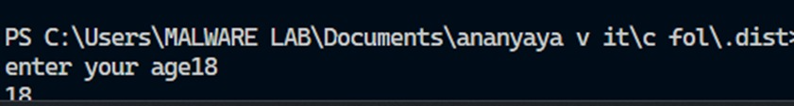
EXPERIMENT 2
Aim: WAP in C to print an integer.
Theory: In C programming, primitive data types like int are used to store whole numbers without decimals. To perform input and output operations on integer variables, the standard I/O library functions scanf() and printf() are utilized along with the format specifier %d. The address-of operator & is required in scanf() to point to the memory location of the integer variable i where the user input will be stored. printf() then retrieves the data from that memory address to display it on the output console
Algorithm:
Step 1: Start
Step 2: Declare an integer variable i.
Step 3: Print a message prompting the user to "enter the int".
Step 4: Read the integer value entered by the user and store it in variable i.
Step 5: Print the value stored in variable i.
Step 6: Stop
Code:
#include <stdio.h>
int main() {
int i;
printf("enter the int: ");
scanf("%d", &i);
printf("%d", i);
return 0;
}
Output:
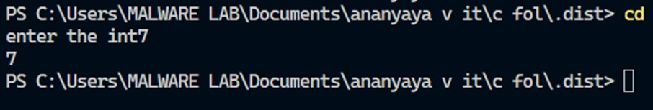
EXPERIMENT 3
Aim: WAP in C to find Simple Interest.
Theory:
Simple Interest calculation is a financial operation used to find the interest earned or paid on a principal sum over a period of time at a specific rate. The mathematical formula is (SI = P * R* T/100), where P is the Principal amount, R is the Rate of interest, and, T is the Time period. Since monetary amounts, interest rates, and time intervals can contain decimal numbers, the float data type is used in C to handle fractional numbers. The format specifier %f is used in scanf() and printf() to handle these floating-point variables.
Algorithm:
• Step 1: Start
• Step 2: Declare floating-point variables p, r, and t to store principal, rate, and time.
• Step 3: Print a message prompting the user to "Enter the principal amount".
• Step 4: Read the floating-point value and store it in variable p.
• Step 5: Print a message prompting the user to "Enter the rate of interest".
• Step 6: Read the floating-point value and store it in variable r.
• Step 7: Print a message prompting the user to "Enter the time period".
• Step 8: Read the floating-point value and store it in variable t.
• Step 9: Calculate the simple interest using the formula (p * r * t) / 100 and print the result.
• Step 10: Stop
Code:
#include<stdio.h>
int main() {
float p, r, t;
printf("Enter the principal amount: ");
scanf("%f", &p);
printf("Enter the rate of interest: ");
scanf("%f", &r);
printf("Enter the time period: ");
scanf("%f", &t);
printf("The simple interest is: %f", (p * r * t) / 100);
return 0;
}
Output:
